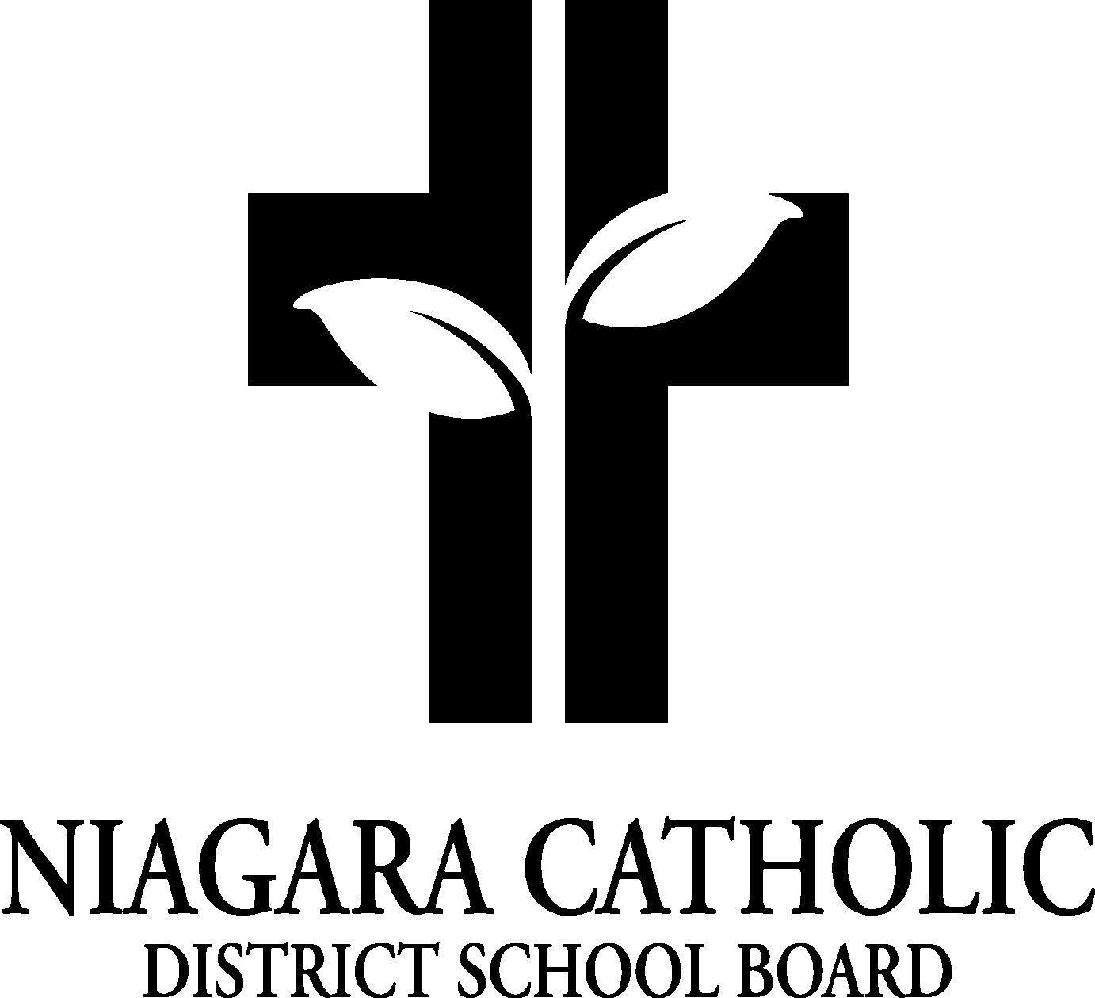

AGENDA
NAME OF SCHOOL CATHOLIC SCHOOL COUNCIL MEETING

DATE
Location

A. ROUTINE MATTERS

- Opening Prayer
- Roll Call
- Approval of the Agenda
- Election of Chair and/or Co-Chairs (when applicable)
- Election of the Ontario Association for Parents in Catholic Education (OAPCE)-
(when applicable)
- Disclosure of Interest
- Approval of Minutes of the Name of School Catholic School Council Meeting of Date

B. PRESENTATIONS

C. PRINCIPAL’S REPORT
- Niagara Catholic Parent Involvement Committee (NCPIC) Report
- Special Education Advisory Committee (SEAC) Report
- Catholic School Council Financial Report

D. CHAIR AND/OR CO-CHAIR’S REPORT

E. POLICY REVIEW AND FEEDBACK

F. STAFF REPORT

G. AGENDA ITEMS-DISCUSSION FOR FUTURE MEETINGS

H. NEXT MEETING

I. ADJOURNMENT

J. CLOSING PRAYER

